**LABOUR DAY 2015**

**HAVEN OF HOPE TOOK AN ACTIVE PART IN THE CELEBERATION OF LABOUR DAY - 1ST MAY 2015**

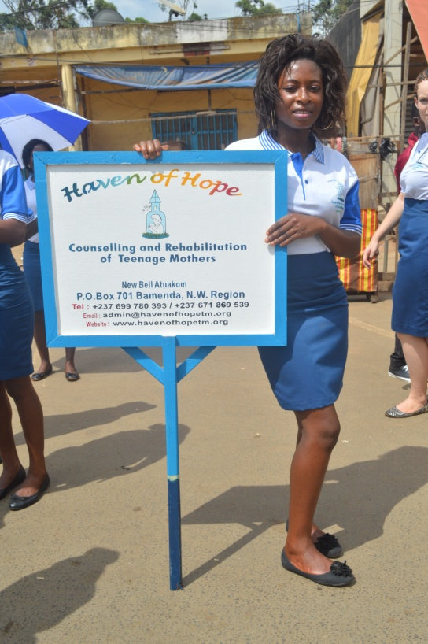 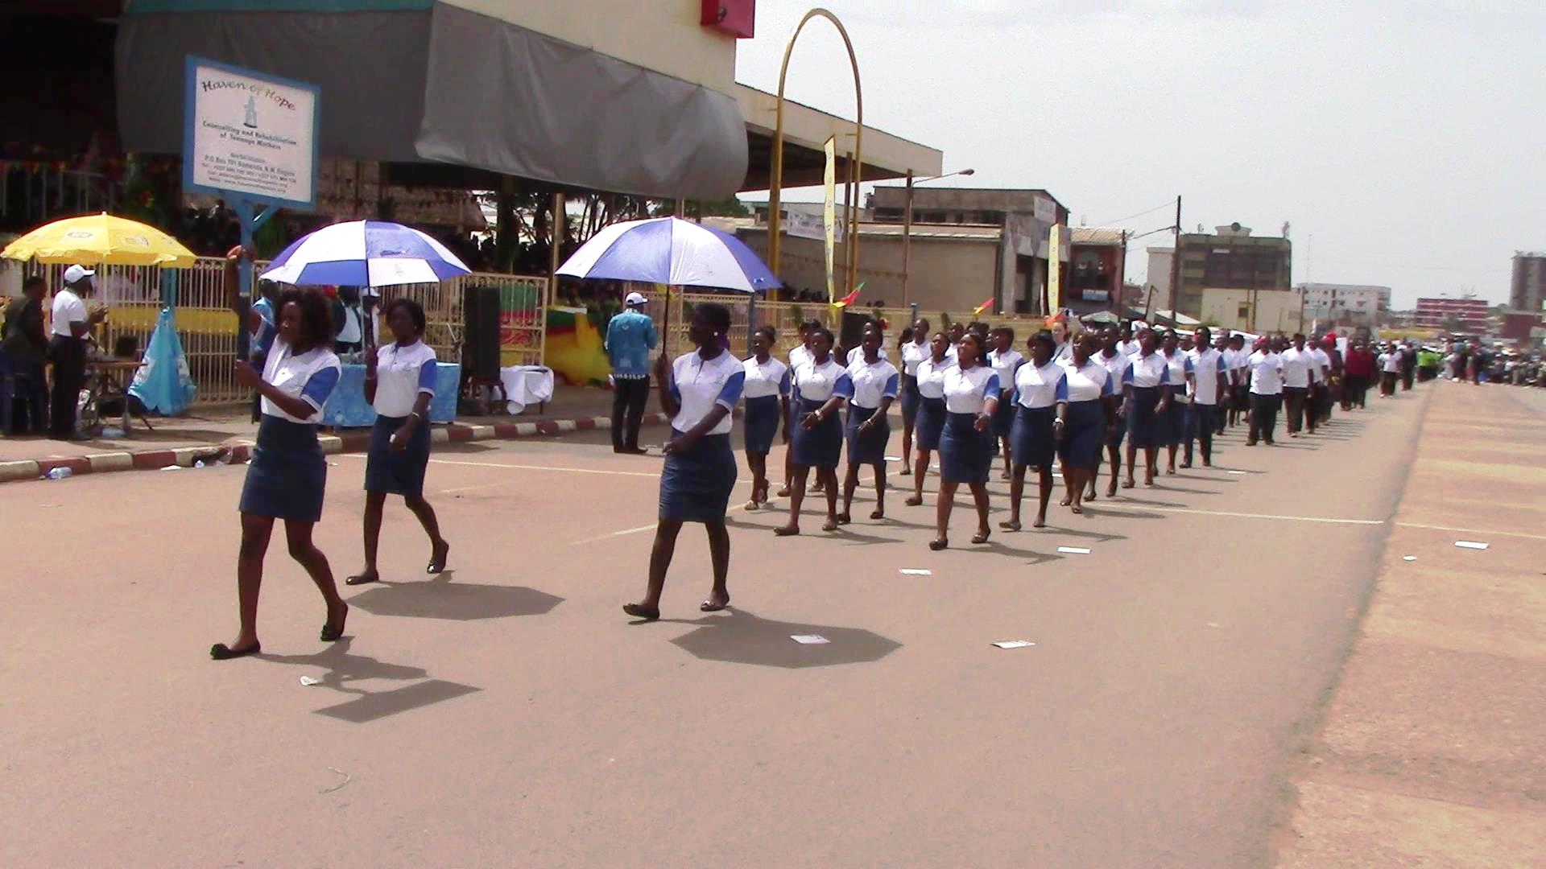

**THE BANNER CARRIER MATCH PASSING INFRONT OF THE GRAND STAND**

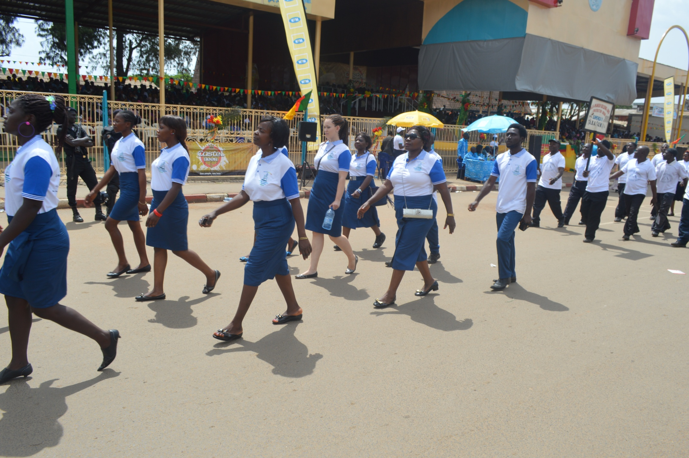 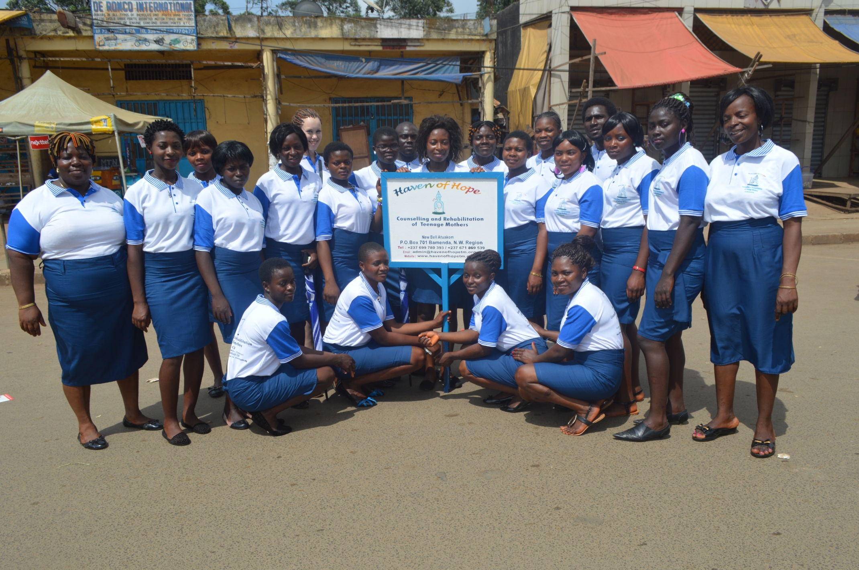

**TALE OF THE QUEUE AFTER MATCH PASS**

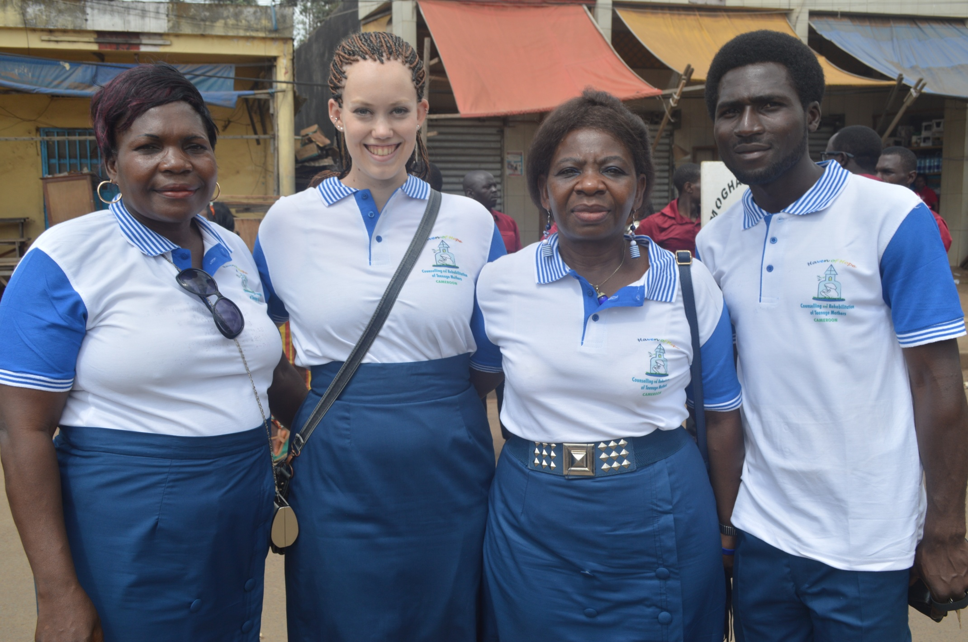 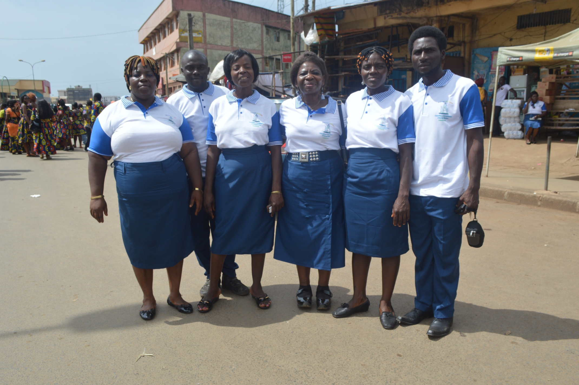

**STAFF OF HOH STAFF & SUPPORTERS OF HOH**

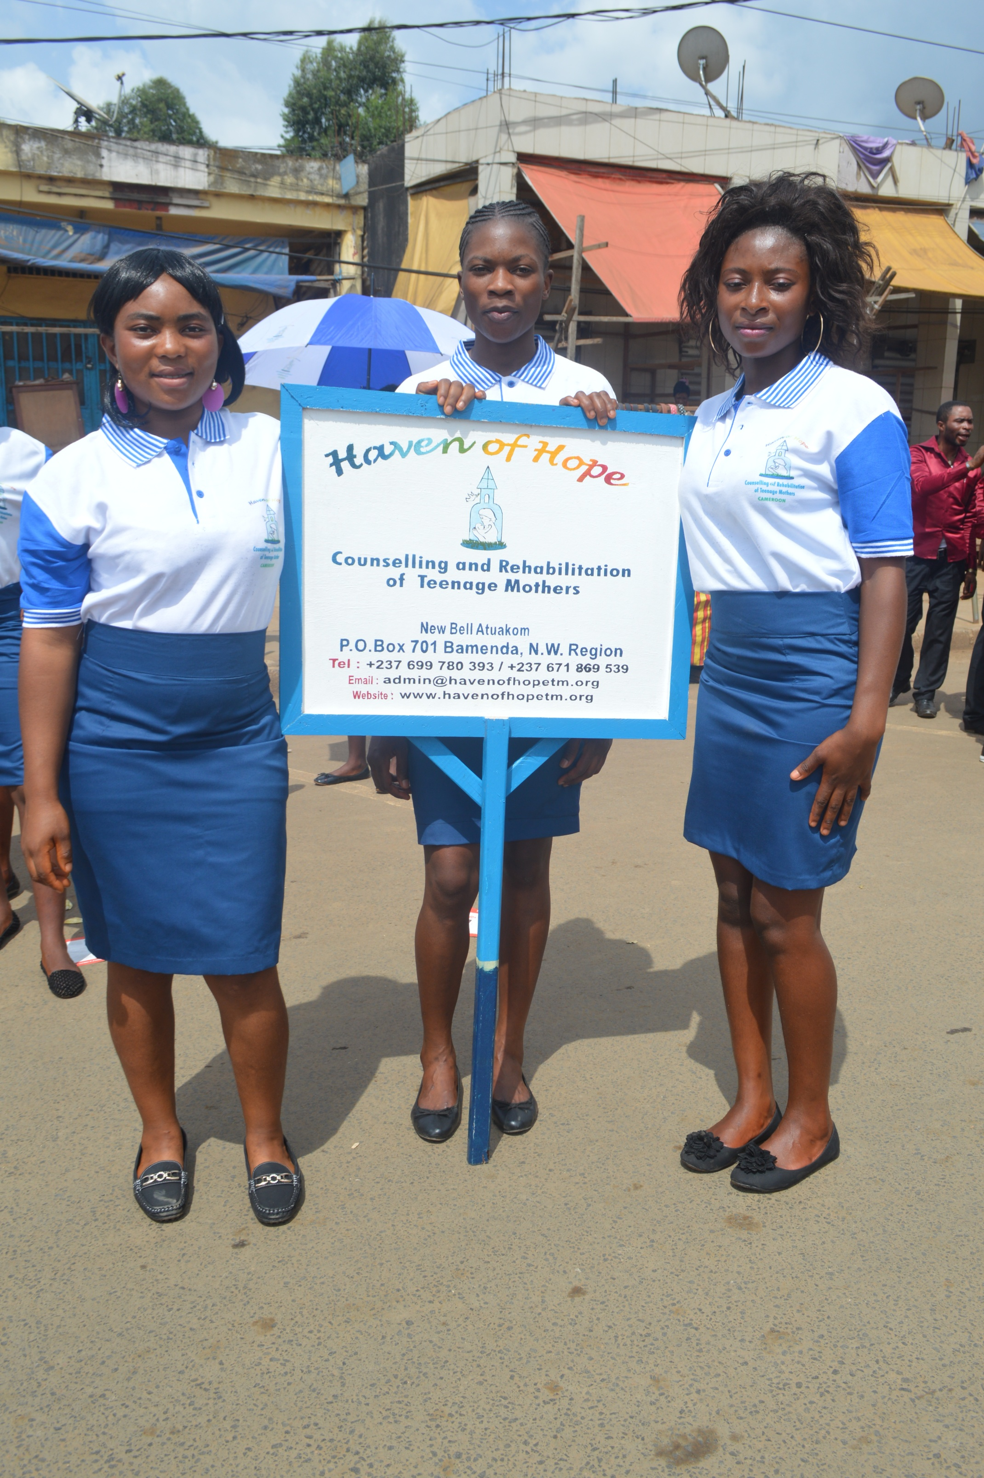 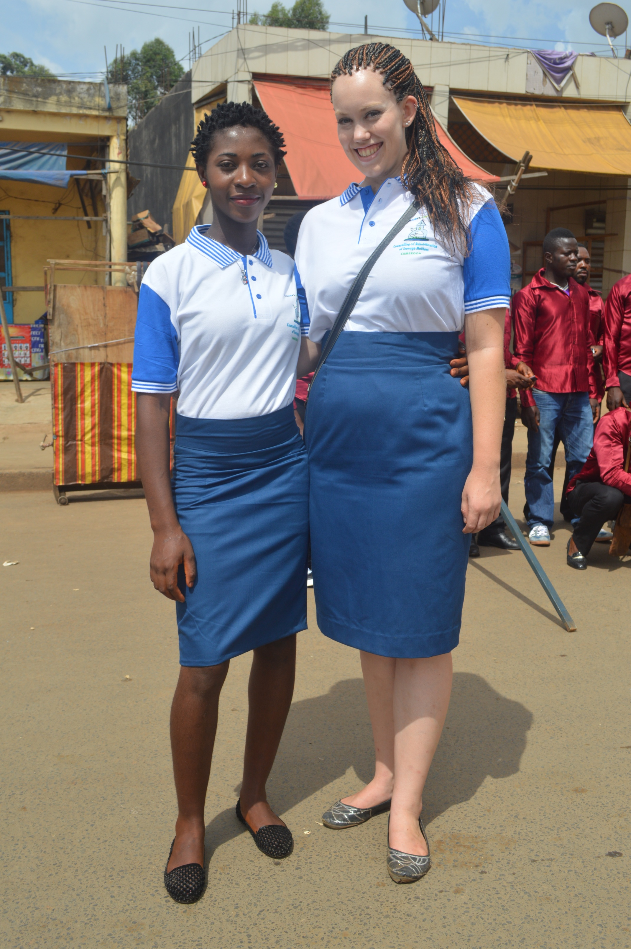 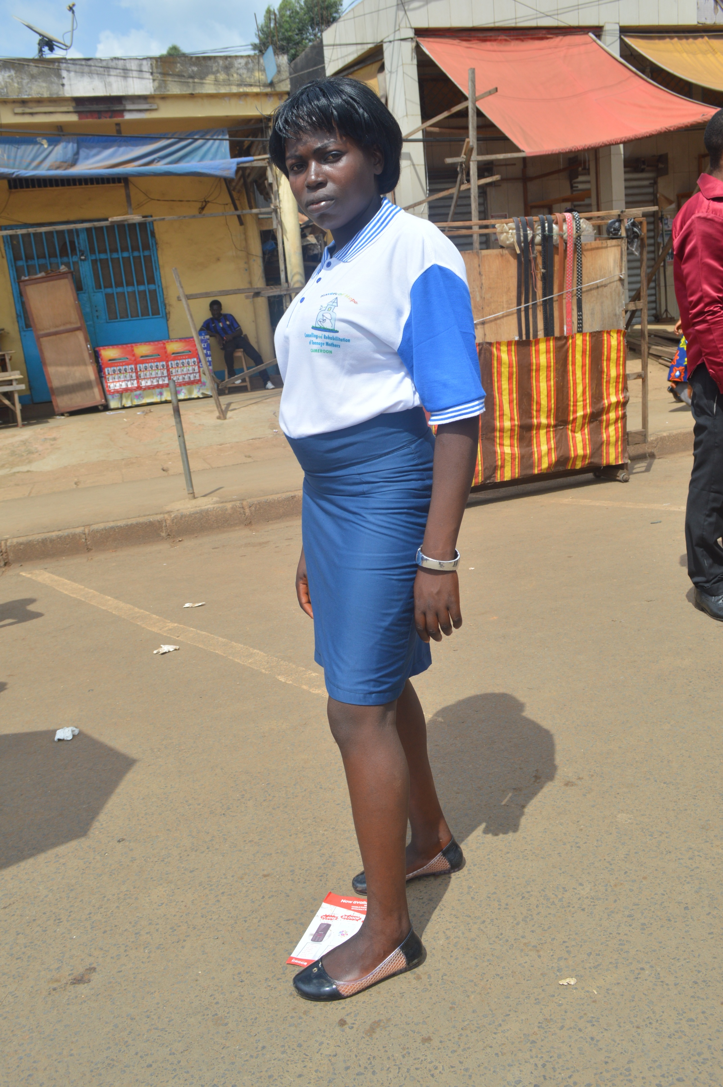

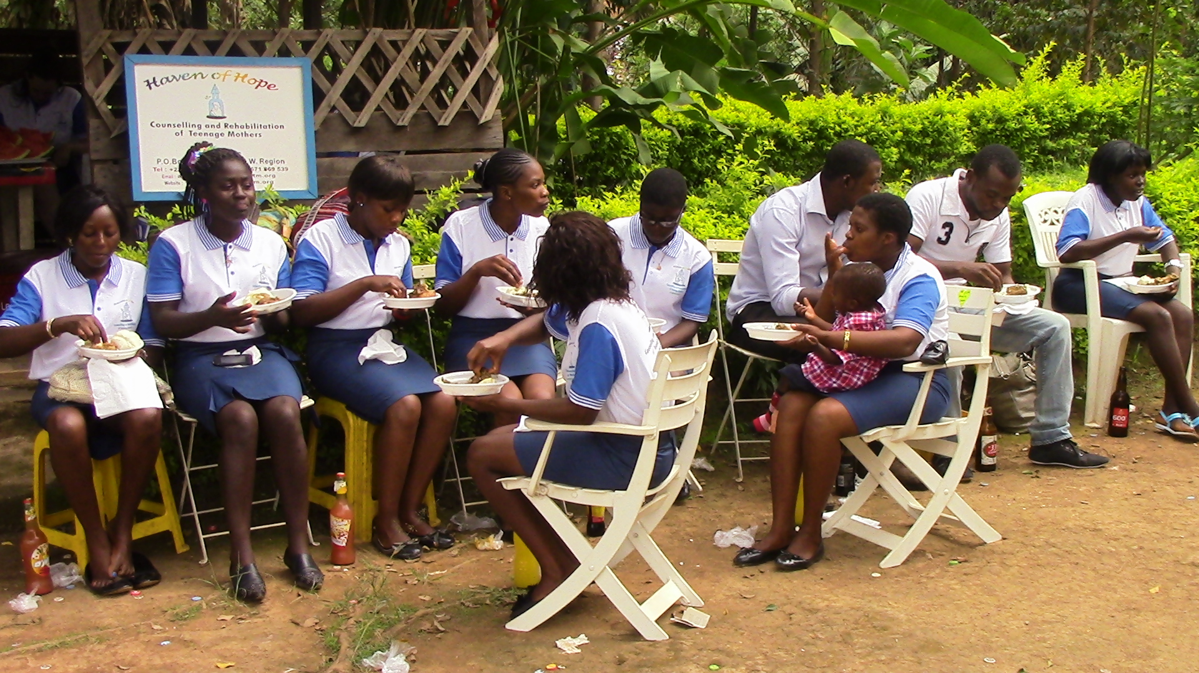 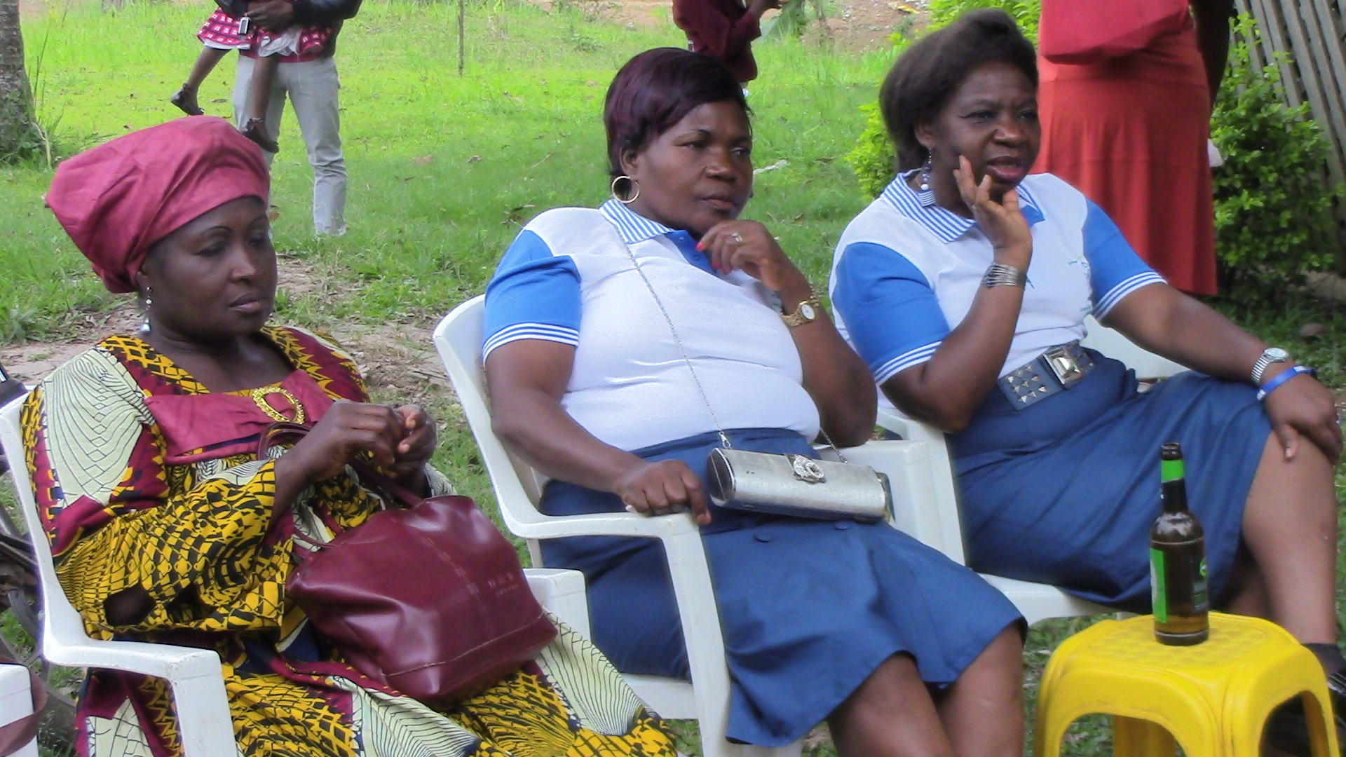

**REFRESHMENT AFTER MATCH PASS RELAXING AT THE END OF DAY**

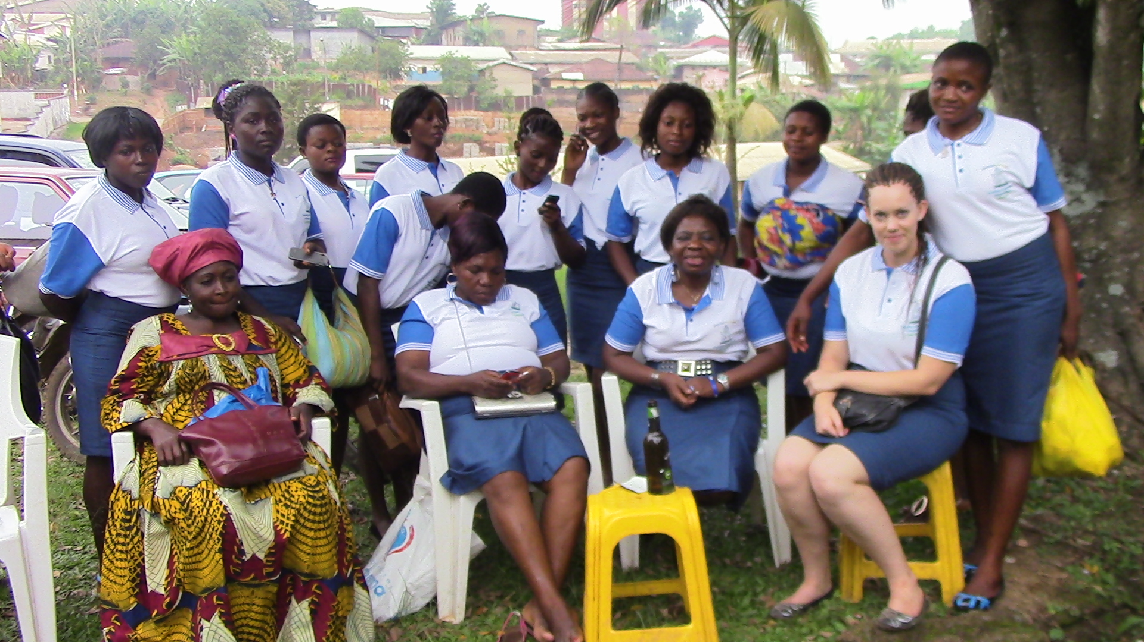

A LAST POSE BEFORE SEPARATING AFTER A CHEERFUL DAY